Report: Note Tracker Web Application

Introduction:

The Note Tracker web application is designed to help users organize and manage their notes effectively. The application allows users to sign up, sign in, add notes, update notes, delete notes, and log out. It also includes an admin panel where administrators can log in, view all user notes, and log out. The application is built using Servlets, JSP, Hibernate, HQL, HTML, CSS, Bootstrap, and MySQL.

Functionality:

User Registration:

Users can sign up by providing their name, email, and password and etc.

The registration data is stored in the MySQL database using Hibernate.

User Login:

Registered users can log in with their email and password.

The application verifies the credentials and grants access to the user dashboard.

User Dashboard:

After successful login, users are redirected to their dashboard.

The dashboard displays a list of their notes with titles and options to update or delete each note.

Users can add new notes by providing a title and content.

Update Notes:

Users can edit the title and content of their existing notes.

The application updates the notes in the database using Hibernate.

Delete Notes:

Users can delete their notes from the dashboard.

The application removes the notes from the database using Hibernate.

Logout:

Users can log out of the application, ending their session.

Admin Login:

Administrators can access the admin panel by providing their credentials.

The application verifies the admin credentials and grants access to the admin panel.

Admin Panel:

After successful login, admins are redirected to the admin panel.

The admin panel displays a list of all users' notes, including the user's name, note title, and content.

Admins have the option to log out from the admin panel.

Technologies Used:

Servlets:

Servlets are used to handle user requests, perform authentication, and interact with the database.

JSP (JavaServer Pages):

JSP is used to create dynamic web pages and display data from the server.

Hibernate:

Hibernate is an ORM (Object-Relational Mapping) framework used for database operations.

It simplifies the database interaction by mapping Java objects to database tables.

HQL (Hibernate Query Language):

HQL is used to write database queries in Hibernate.

It allows developers to write queries using Java objects instead of SQL.

HTML, CSS, and Bootstrap:

HTML is used for creating the structure of web pages.

CSS is used for styling the web pages.

Bootstrap is a CSS framework that provides pre-designed UI components for a responsive and visually appealing design.

MySQL:

MySQL is used as the database management system to store user data and notes.

Here are some visuals of Web Application (NoteTracker)

Home Page:

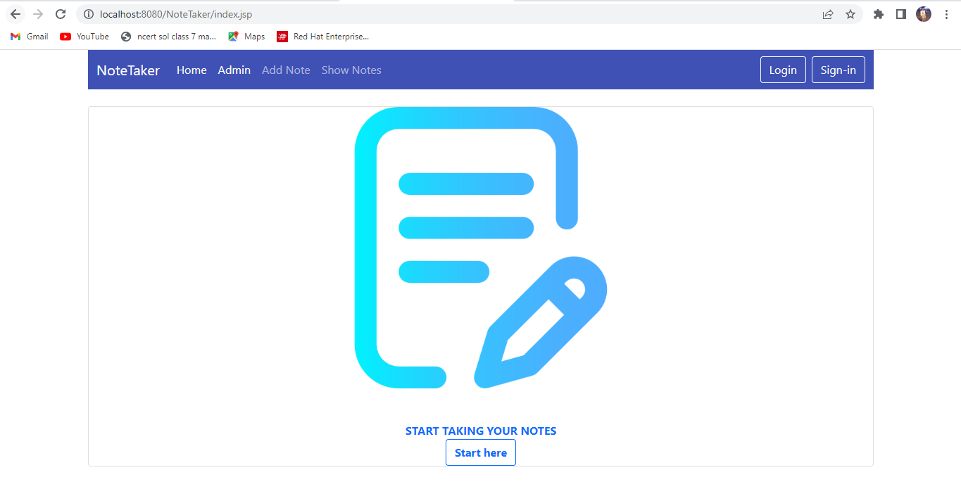

Sign-in Page

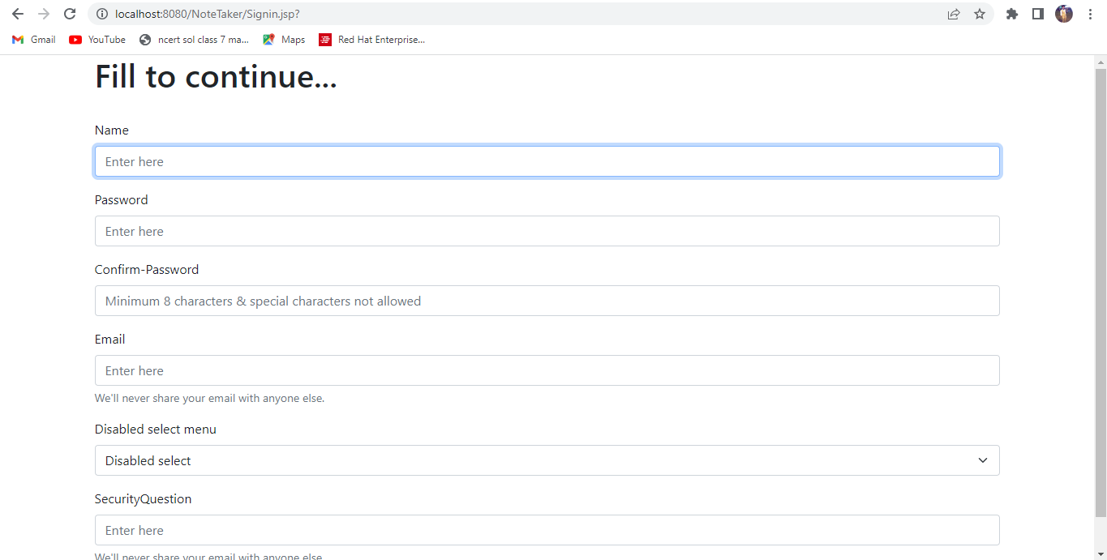

Login-in Page:

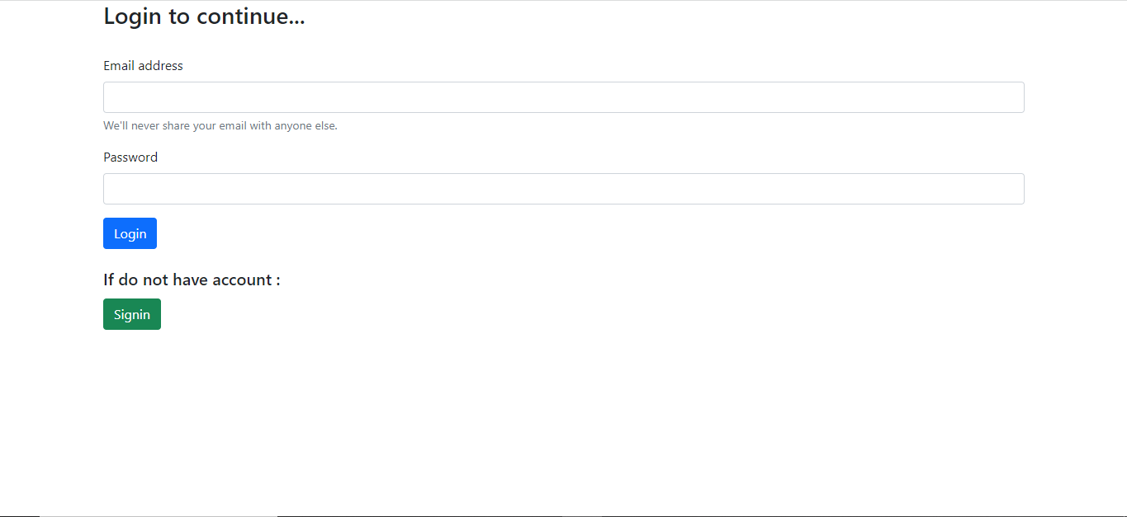

User Home Page:

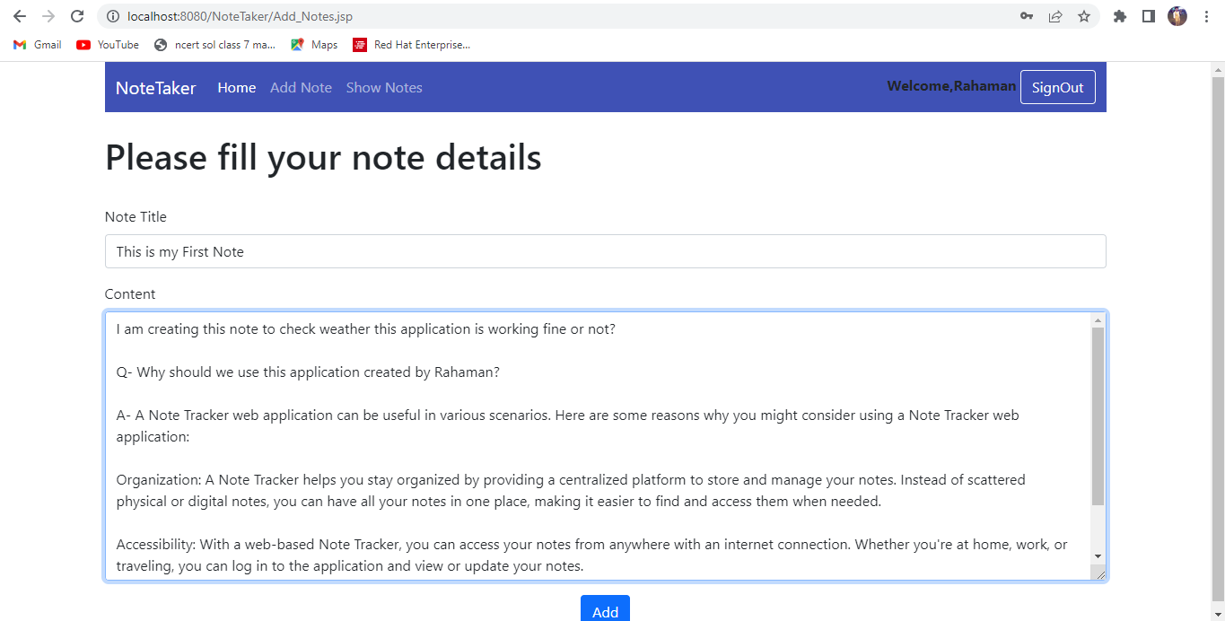

Saved Successfully:

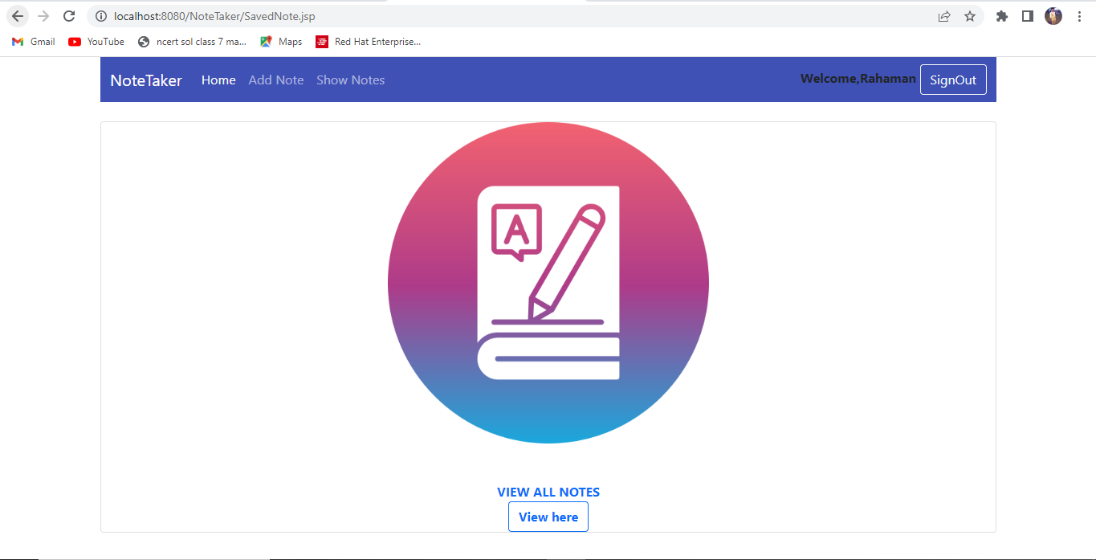

View Notes:

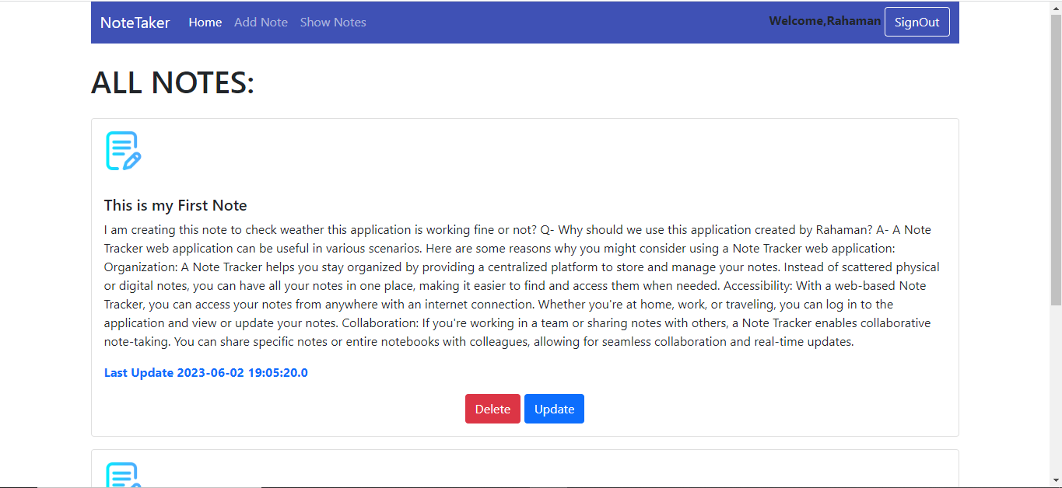

Update Notes:

While Updating….

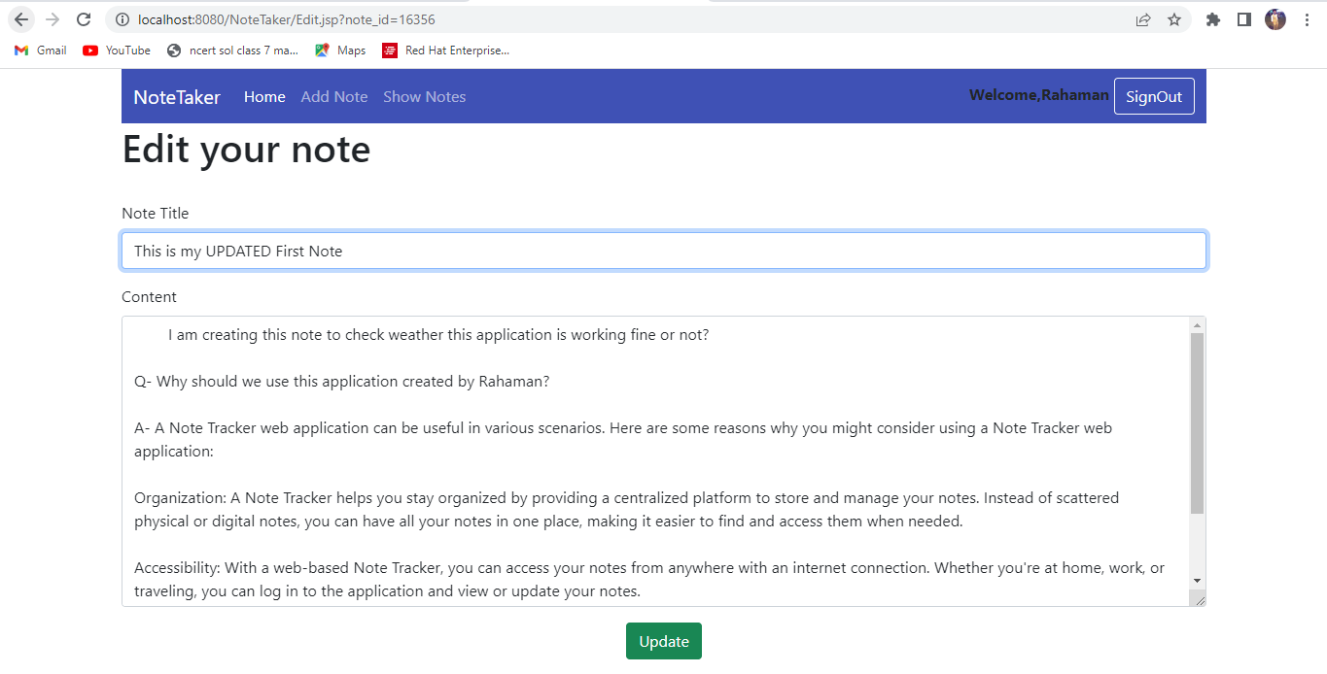

Updated….

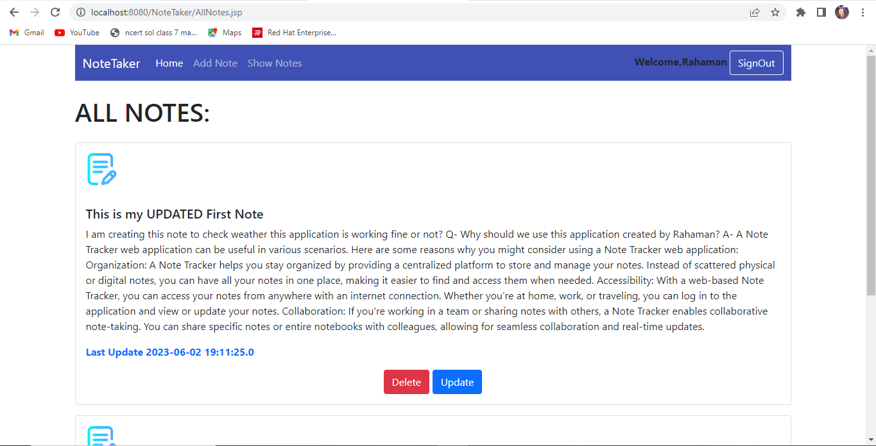

Admin Login:

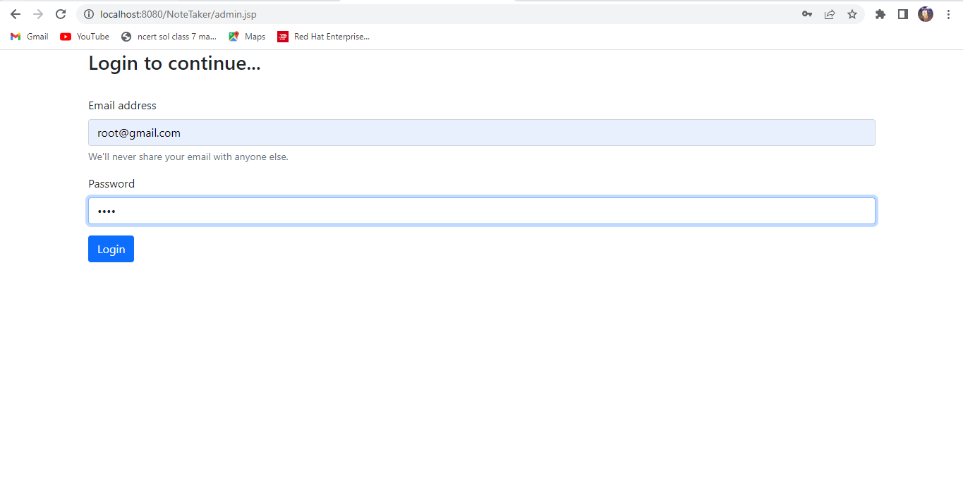

Admin Home:

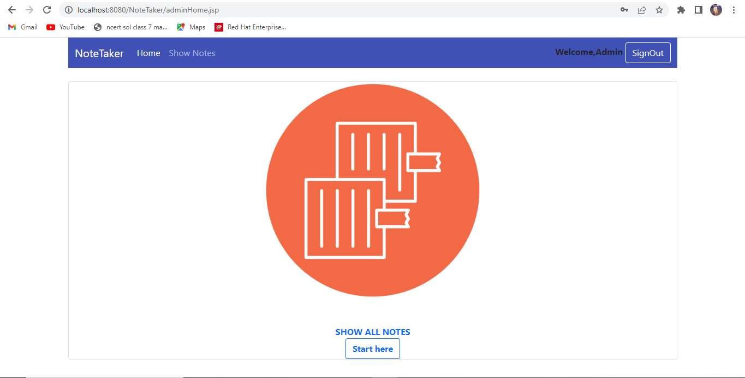

All Users Notes:

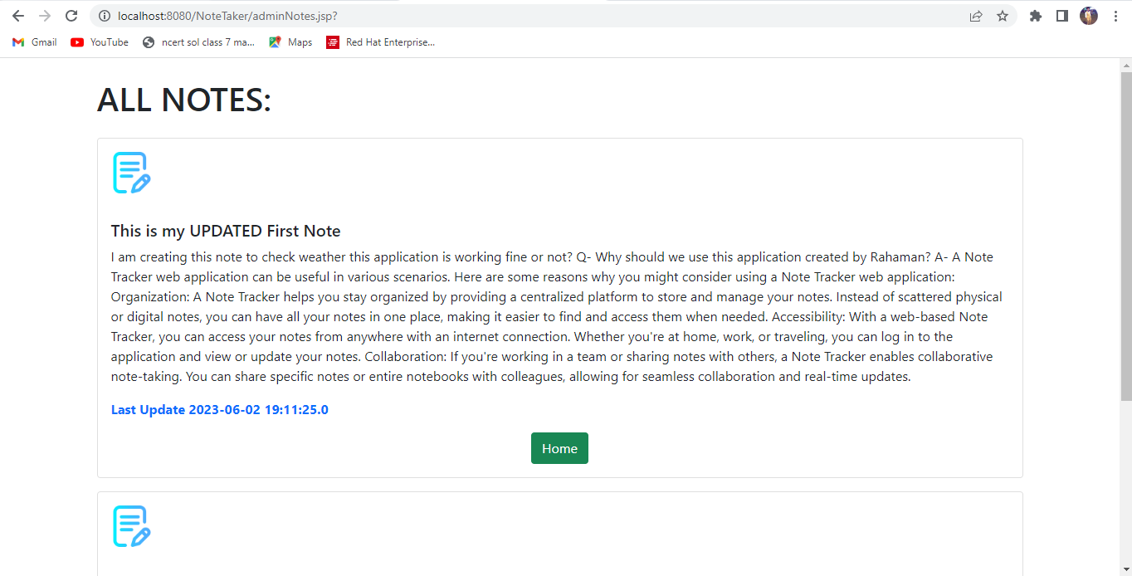

Conclusion:

The Note Tracker web application provides users with a convenient way to manage their notes. It allows users to sign up, sign in, add notes, update notes, delete notes, and log out. The application also includes an admin panel for administrators to view all user notes. By leveraging Servlets, JSP, Hibernate, HQL, HTML, CSS, Bootstrap, and MySQL, the application offers a robust and user-friendly experience for note tracking and organization.